**RESUME**

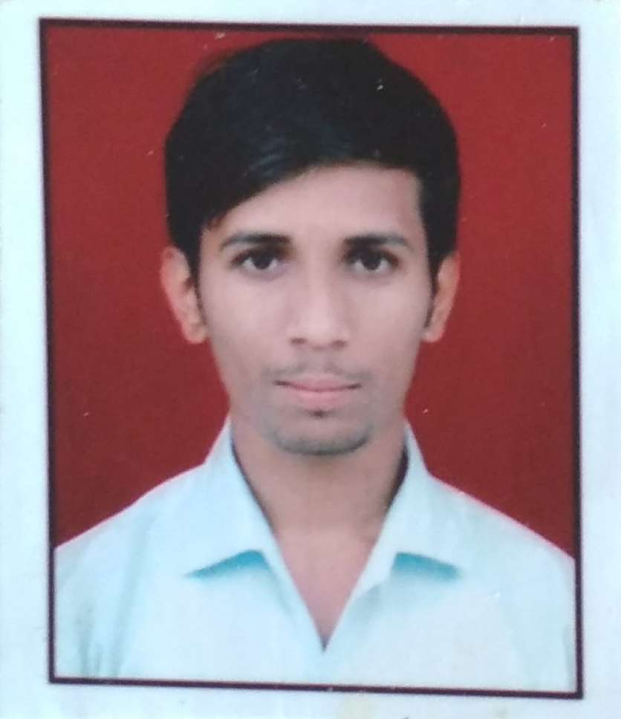

|  |  |
| --- | --- |
| **Sohan Sonar** | |
| **E-mail ID :** sohan.nsonar@gmail.com | |
| **Nationality :** | Indian |
| **Contact No :** 9021562189 | |

**CAREER OBJECTIVE:**

To secure a challenging position where I can effectively explore my knowledge as well as skills as a Software Professional possessing competent technical skills in the area of Software Development and give my best services to the organization.

**PROFILE**:

**Summary**:

* Over 4.6+ year of experience in IT Industry in PHP (Core) using Laravel, Wordpress, and PHP as well acquainted with software development life cycle.
* Over 6 month of training experience in Nashik in PHP 5.0 using core and Advanced PHP well acquainted with software development life cycle.
* Over 9 month experience in Prism Life Sciences ,Mumbai in PHP using Core, PHP MyAdmin, Bootstrsap, CSS3, HTML5 well acquainted with software development life cycle.
* Proficient knowledge in PHP MyAdmin, Domain & Hosting, Boot-Strap, CSS3 , HTML5 , CodeIgniter ,Angular 2.0 , Apache server technologies , REST Api webservices.
* I would take up assignments with enthusiasm and challenges, playing positive role in the team and ability to interact with individuals at all levels.

**CERTIFICATION:**

* PHP Certified .
* Ethical Hacking and Cyber Security.
* 4 month Training on live Project in Java Technology.

**PROFESSIONAL EXPERIENCE:**

* Working as Sr. PHP Developer in Affaltus Web Technologis Pvt. Ltd , Mumbai from May 2018 to till date.
* Worked as Web Developer With Angular 2.0v in TDK Groups for 8 Months.
* Web Developer in V. K. Lalco Pvt. Ltd, Mumbai from June 2015 to Aug 2017.

**EDUCATIONAL QUALIFICATION:**

|  |  |  |  |  |  |
| --- | --- | --- | --- | --- | --- |
| S. No | Name of Exam | Institute | Name Of’  University/  Board | Year Of  Passing | Result/  Aggregate  (%) |
| 1. | BE – Computer Science  &  Engineering | Sapkal knowledge Hub college Of engineering | Savitri Bai Phule (Pune) university | 2015 | 61.00 |
| 2. | Diploma in IT | G.G.S Polytechnic | Savitri Bai Phule (Pune) university | 2012 | 68.00 |
| 3. | SSC 10th | Bhonsla Military School | Maharashtra Board | 2009 | 75.00 |

**TECHNICAL SKILLS:**

Programming Languages : PHP, Javascript, Rest API Services, Python 3 (Basic).

Frame-Work Environment : Wordpress, Laravel 5.7, Magento Basic

Database Language : SQLi, PDO(Basic)

Scripting Language : HTML,Javascript,Html5,CSS

Operating System : WINDOWS XP, 2003,7,8 ,Ubantu

IDE/ Tool : ATOM,Sublime, Pychamp.

Server Technology : Apache

**PROJECT DESCRIPTION:**

**Project #1**

|  |  |
| --- | --- |
| Title | Website consultancy |
| Client | Vector Group Thane |
| Role | Developer |
| Project Name | https://www.vectorconsulting.in/ |
| Environment | Wordpress, REST API, |
| Work Location | Mumbai |
| Duration | Deployed |
| Description | This website is developed as combination of social site as well as consultancy management this one is fully dynamic website by which user can access each and everything what he needs about requirement with integration of multiple payment gateways. |

**Project #2**

|  |  |
| --- | --- |
| Title | Web Application |
| Client | Unilever food solution |
| Role | Developer |
| Project Name | https://www.unileverfoodsolutions.co.in/ |
| Environment | Wordpress, PHP, PhpMyadmin, HTML, CSS, Bootstrap, |
| Work Location | Mumbai Andheri |
| Duration | Working |
| Description | This Client project which was well known brand Unilever Foods it is been developed for their own product and recipe . even user can purchase online product from there store. |

**Project #3**

|  |  |
| --- | --- |
| Title | Web Application |
| Client | Affaltus Web Technologies Pvt. Ltd |
| Role | Developer |
| Project Name | TMT (Time Management tracker) & LMS |
| Environment | PHP, AJAX, Javascript, PhpMyadmin, HTML, CSS, Bootstrap |
| Work Location | Mumbai Nariman Point |
| Duration | Working |
| Description | This is the company product and worked to get the real tracking of daily work of employees from Application using PHP, AJAX, Javascript,HTML. So we get the data from Application stored in our database (SQL) For Future requirement.  User can able to create their task will be updated till finishing the task & same will be visible to respective Manager & director. Manager can able to approve task if all thing is done properly or can also disapprove.  Users will receive an email of his/her pending task if requested due date is exceeded for any task. |

**Project #4**

|  |  |
| --- | --- |
| Title | Web Application |
| Client | Lalco interiors |
| Role | Developer |
| Project Name | IJ- Inventory Jobs |
| Environment | PHP, Ajax, Javascript, CSS, HTML, bootstrap, Angular 2.0V |
| Work Location | Mumbai |
| Duration | Working |
| Description | This is a Client Product for Furniture Showroom to get inventory of products  With Pricing of Products,Purchase of product, Selling of Product, realtime count of products, Generating Bills as per Financial regulations and Much more.  Products are stored on server alongwith their images & images stored in AWS. |

**Project #5**

|  |  |
| --- | --- |
| Title | Website |
| Client | Prism Life Sciences Ltd. |
| Role | Web Developer |
| Project Name | PRISMILE Website |
| Environment | HTML, CSS, Bootstrap, PHP |
| Work Location | Navi Mumbai |
| Duration | 30 days |
| Description | This is a pharmaceutical website have static structure throughout with some CRUD operation performed on some pages |

**Project #6**

|  |  |
| --- | --- |
| Title | Web Application |
| Client | Prism Life Sciences Ltd. |
| Role | Developer & Administrator |
| Project Name | Dataware House System & CRM Application |
| Environment | Php7.0, Jquery, Javascript. MySqli, Ajax |
| Work Location | Navi Mumbai |
| Duration | 3 Months |
| Description | This product refers to the Product shiping system for international market with invoice generation for Product as per Pharma regulation.  Which includes stock inventory for different category product. Product can be tracked by ther unique package number.  And Handling of third party CRM application of Pharmaceutical industry for MR/Manager/Doctors. |

**Project #7**

|  |  |
| --- | --- |
| Title | Web Application |
| Client | Netwin Infosolution Ltd. |
| Role | Developer |
| Project Name | Plumbing |
| Environment | CodeIgniter, PHP, HTML, Bootstrap, Angular 2.0V |
| Work Location | Nashik |
| Duration | 6 Months |
| Description | This product is developed for Foreign based client, Plumbing application is all about online plumbing system for those wo need service at home directly.  This application is Combination of webapp, Android & for IOS also.  Php libraries are created and linked to Android and IOS. So that user will get realtime push notification.  Updation done in mobile app will reflect immediately on other two. |

**Project #8**

|  |  |
| --- | --- |
| Title | E-Commerce Website |
| Client | V. k. lalco pvt. Ltd. |
| Role | Developer |
| Project Name | E-Commerce Website |
| Environment | Mgento Community v1.9.0.1 |
| Work Location | Mumbai |
| Duration | 6 Months |
| Description | This Product is E-commerce website to sell Interior product online |

**Project #9**

|  |  |
| --- | --- |
| Title | Website |
| Client | V. K. Lalco Pvt. Ltd. |
| Role | Developer |
| Project Name | VKLALCO.COM |
| Environment | Wordpress, PHP |
| Work Location | Mumbai |
| Duration | 1 Month |
| Description | This is Companies own website which is developed in Wordpress platform. |

**Project #10**

|  |  |
| --- | --- |
| Title | Website |
| Client | Green wayn LLC |
| Role | Developer |
| Project Name | Greenwayn.com |
| Environment | Wordpress, CSS, HTML |
| Work Location | Mumbai |
| Duration | 1 Month |
| Description | This website is developed for one of our client from new York.  As per clients request we have developed website from their given PSD files |

**Project #11**

|  |  |
| --- | --- |
| Title | Website |
| Client | Lalco Residency |
| Role | Developer |
| Project Name | Hoptality Website |
| Environment | Wordpress, PHP, HTML, CSS, Payment-Gateway |
| Work Location | Mumbai |
| Duration | 2.5 Months |
| Description | This website is developed for hospitality management this one is fully dynamic website by which user can book rooms and checked in. with integration of multiple payment gateways. |

**EXTRA CURRICULAR ACTIVITY:**

* Attended 3 days of Ethical Hacking and Cyber Security Workshop.
* Attended 2 days of Android Workshop.
* Participated in various Quiz in college time.

**STRENGTHS:**

Determined, Optimistic, Patient & Helpful.

**HOBBIES:**

* Surfing on Internet.
* Like to draw cartoons
* Gardening

|  |  |  |
| --- | --- | --- |
| **PERSONAL DETAILS** | : |  |
| D.O.B. | : | 25.June.1994 |
| Gender | : | Male |
| Marital Status | : | Married |
| Nationality | : | Indian |
| Languages Known | : | Marathi, Hindi, English |
| Permanent Address | : | Sr. No 126/1B Plot No. 5 Shree Swami Samartha Bunglow,  Shivaji Nagar, Satpur Nashik 422012 |
|  |  | Mb: 9021562189 |

I here by declare that all the information provided by me is correct to best of my knowledge.

Place: NASHIK, Maharashtra, India

Date: [Sohan N. Sonar]